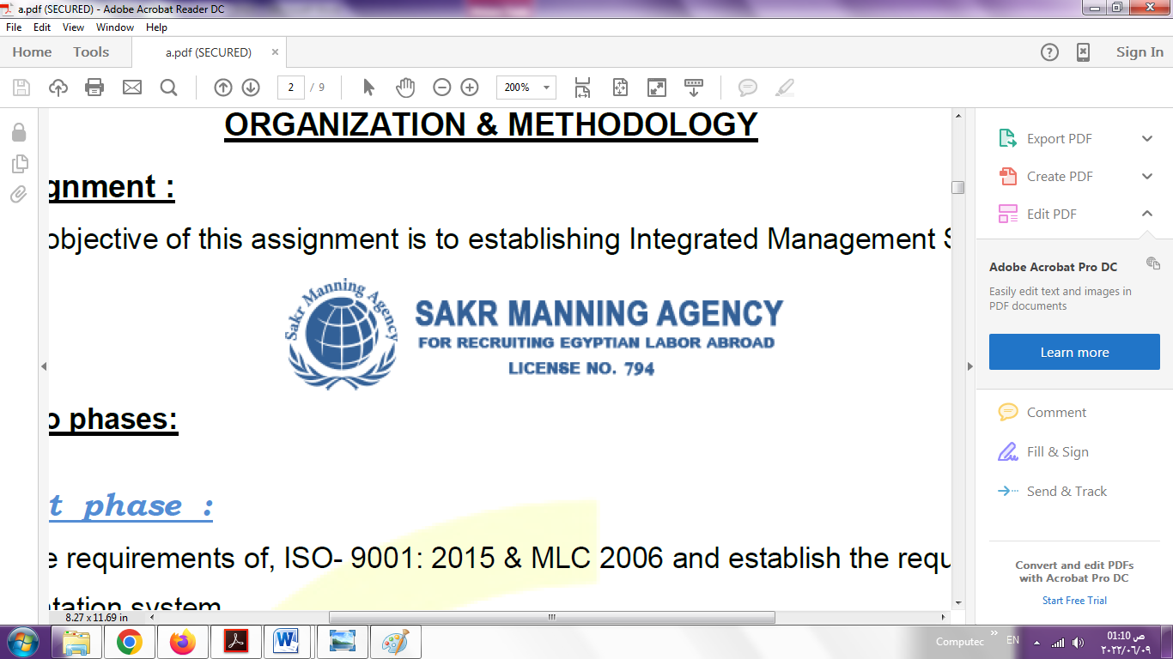 | SAKR MANNING AGENCY  FOR RECRUITING EGYPTIAN LABOR ABROAD | Issue Date | 15.05.2022
 |  | Revision Date | 19.07.2022
 | Crewing Management Manual  Seafarer Employment Application | Revision | 1.1
 |  | Page | 3


Application For Position as | Oiler
Register Code. | ER-3.016
Other Position (If Any) | Engine Cadet , Mechanic
Register Date | 16/11/2022
Last up Date Data | 5/10/2022
Expected Salary | 600 - 1000 $

1. PERSONAL DETAILS
Full Name |  | Mustafa Mahmoud Hemdan Mekled
Date Of Birth |  | 27/8/1996 |  |  |  |  |  |  | Place Of Birth |  |  |  |  |  |  |  | Qatar
Nationality |  | Egyptian |  |  |  |  |  |  | Marital Status |  |  |  |  |  |  |  | Single ☐ |  |  |  |  |  |  |  | Married ☐
Height (Cm) |  | 173 |  |  |  |  |  |  | Overall Size |  |  |  |  |  |  |  | XXL |  |  |  |  | Shirt Size |  |  |  |  |  | XXL
Weight (Kg) |  | 90 |  |  |  |  |  |  | Trouser Size |  |  |  |  |  |  |  | 38 |  |  |  |  | Shoes Size |  |  |  |  |  | 45
2. EDUCATION
College / School |  | Alexandria Higher institute of Engineering and Technology
Marline Test |  | Issued Date |  |  |  |  | Result % |  |  |  | Issued By (Authority) |  |  |  |  |  |  |  |  |  | Issued At
English Language |  | Fluent ☐ |  |  |  |  |  | Good ☐ |  |  |  |  | Average ☐ |  |  |  |  |  |  |  | Poor ☐
……… Language  ( Arabic ) |  | Fluent ☐ |  |  |  |  |  | Good ☐ |  |  |  |  | Average ☐ |  |  |  |  |  |  |  | Poor ☐
3. CONTACT DETAILS
Home Address / City |  |  | 58 Saif Street, Sidi Bishr no 404 Alexandria, Egypt
E-Mail |  |  | Mustafahemdan66@gmail.com |  |  |  |  |  |  | Mobile / Tel |  |  |  |  |  | +201028780693

4. TRAVEL DOCUMENTS
Type |  | Document No. |  |  |  | ISS. Date |  |  | Exp. Date |  |  |  |  | ISS. By (Authority) |  |  |  |  |  |  |  |  |  | Place of Issue
Passport |  | A30844837 |  |  |  | 02/07/2022 |  |  | 01/07/2029 |  |  |  |  | Egyptian Authority |  |  |  |  |  |  |  |  |  | ALEX / EGY
Seaman Book |  | S00023498 |  |  |  | 21/06/2022 |  |  | 14/06/2027 |  |  |  |  | EAMS |  |  |  |  |  |  |  |  |  | Alex.
Other Seaman Book

5. PROFESSIONAL QUALIFICATION / CERTIFICATE OF COMPETENCY
Certificate Name |  |  |  |  | Number | Issue Date |  |  |  |  |  | Expiry Date |  |  |  |  |  | Issued By |  |  |  |  |  |  |  |  | Issued At
COC |  |  |  |  |  |  |  |  |  |  |  |  |  |  |  |  |  | EAMS |  |  |  |  |  |  |  |  | Alex.
GOC |  |  |  |  |  |  |  |  |  |  |  |  |  |  |  |  |  | NTRA |  |  |  |  |  |  |  |  | Cairo
D.P. INDUCTION
D.P. ADVANCED
D.P. OPERATOR (UNLIMITED)
6. NEXT OF KIN
Full Name | MAHMOUD HEMDAN MEKLED |  |  |  |  |  |  |  |  |  |  |  |  |  | Relationship |  |  |  |  | parent
Address | 58 Saif Street, Sidi Bishr no 404 Alexandria, Egypt
Tel. No. |  |  |  |  |  |  |  |  |  | Mobile
7. HEALTH CERTIFICATES & VACCINATIONS
Flag State |  |  |  | Number |  |  | Issue Date |  |  |  |  | Expiry Date |  |  |  |  |  |  | Issued By |  |  |  |  |  |  | Issued At
International Medical |  |  |  | 03510 |  |  | 28/06/2022 |  |  |  |  | 27/06/2024 |  |  |  |  |  |  | EAMS |  |  |  |  |  |  | Alex.
Yellow Fever |  |  |  | 1195 |  |  | 28/06/2022 |  |  |  |  | permanent |  |  |  |  |  |  | Ministry of Health |  |  |  |  |  |  | Alex
Cholera |  |  |  | N/A |  |  | - |  |  |  |  | - |  |  |  |  |  |  | Ministry of Health
Covid-19 |  |  |  | Vaccination Name |  |  | First Dose |  |  |  |  | Second Dose |  |  |  |  |  |  | (PIN CODE 2653 )
 |  |  |  | johnson and johnson |  |  | 02/07/2022

8. MARINE COURSES
Course Name | Number | Issue Date | Expiry Date | Issued By / At
Personal Survival Techniques | NPST 5313 | 18/06/2022 | 18/06/2027 | NAVAL POST -GRADUATE STUDIES INSTITUTE
Proficiency In Personal Survival Techniques
Fire Prevention and Fire Fighting | NFF 4210 | 23/06/2022 | 18/06/2027 | NAVAL POST -GRADUATE STUDIES INSTITUTE
Advanced Fire Prevention and Fire Fighting
Elementary First Aid | NFA 5487 | 26/6/2022 | 20/6/2027 | NAVAL POST -GRADUATE STUDIES INSTITUTE
Medical Care Studies
Personal Safety and Social Responsibilities | NPS4290 | 26/6/2022 | 20/6/2027 | NAVAL POST -GRADUATE STUDIES INSTITUTE
Proficiency Of Security Awareness Training Seafarers | NA 7841 | 26/6/2022 | 21/6/2027 | NAVAL POST -GRADUATE STUDIES INSTITUTE
Proficiency as a ship Security officer ( PSSO )
Proficiency In Survival Craft & Rescue Boats | XNC500 | 10/10/2022 | 4/10/2027 | NAVAL POST -GRADUATE STUDIES INSTITUTE
G.M.D.S.S
Communications
Advanced Communications
ECDIS Advanced Simulator (Management Level)
ECDIS Simulator (Operation Level)
Prevention and Combating of Marine Pollution
Radar & ARPA Simulator and Search &rescue
ARPA Simulator and Search
Marine Radar and automatic Radar Plotting
Bridge resource Management (B.R.M)
Engine resource Management (E.R.M)
Navigational Watch keeping
Proficiency for Rating forming part of Navigational watch (II/4) |  |  |  | EAMS / Alex.
High voltage training – operation of ship (1000 Volt and More)
Passenger Safety Cargo Safety and Hull integrity
Crowd Management Training
Crisis Management and Human Behavior Training
Safety training for Personal Prov. Direct Passengers
Practical Ability to Prepare Meals and (MLC 2006)
Personal Hygiene and Envir. Protection (MLC 2006)
Safety and Health in the Provision Meals (MLC 2006)
Food Storage and inventory Control (MLC 2006)
Ships Cook Certificate (MLC 2006) |  |  |  | EAMS / Alex.
Abel Seafarer Deck
Proficiency for Abel Seafarer Deck ( II/5 ) |  |  |  | EAMS / Alex.
Engineering Watch keeping |  |  |  | EAMS / Alex.
Proficiency for Rating forming part of a watch in engine room
Abel Seafarer Engine
Proficiency for Abel Seafarer Engine ( III/5 ) |  |  |  | EAMS / Alex.
Electro Technical Rating
Proficiency for Electro Technical rating ( III/7 ) |  |  |  | EAMS / Alex.

COMPLETE SEA – SERVICE DETAILS

Name: |  |  |  |  |  |  |  | Rank: |  |  |  |  |  |  |  | Register Code:
Company Name |  |  | Rank |  | Vessel Name |  |  |  | Signed On |  |  | Signed Off |  |  |  | Period |  |  | Vessel Type |  | D.W.T. |  |  |  |  | Engine Type |  |  | BH | KW
SPECIALISED EXPERIENCE
Name |  |  |  |  |  |  |  |  |  | Type |  |  |  | From |  |  | To |  |  |  |  | Comments
I declare that the information I have given is, to the best of my knowledge, true and complete. I also declare that the documents submitted are genuine, given and sign by persons whose names appear on them.
 |  |  |  |  |  |  |  |  |  |  |  |  | 11/9/2022 |  |  |  |  |  |  |  |  |  | MUSTAFA HEMDAN
 |  |  |  |  |  |  |  |  |  |  |  |  |  |  | DATE |  |  |  |  |  |  |  |  |  | SIGNATURE

